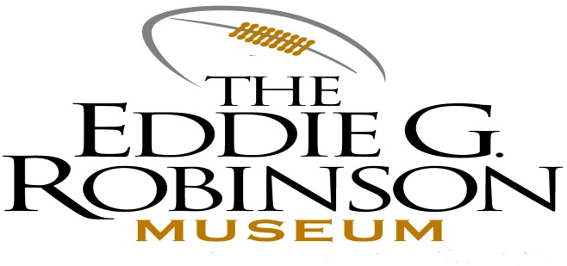
FEBRUARY 3, 2014

PLEASE BE INFORMED THAT

THE EDDIE G. ROBINSON MUSEUM

COMMISSION WILL HOLD ITS ANNUAL M
MEETING HERE ON

FEBRUARY 13, 2014 AT 4:00 PM

IN THE DORIS ROBINSON

BANQUET HALL.

THE PUBLIC IS INVITED TO ATTEND

